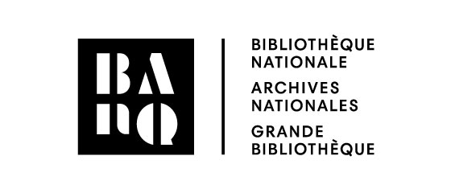 | Parental consent –  Access to all collections

The parent or guardian of a child age 11 or younger can request that the latter be granted access to the adult collections. Age-based access restrictions still apply for films rated 13 and older and for video games rated 12 and older. If the parent or guardian is not present at the time of the request, the child must present this form, completed and signed by their parent or guardian.

Contact information of the child
Last name: |  | Date of birth:
First name: |  | Customary first name (if any):
Address (number, street): |  | Apartment:
City, province: |  | Postal code:
Client number:

Contact information of parent or guardian
Last name:
First name: |  | Customary first name (if any):
Phone: |  | Email:

I have read and understand BAnQ’s Règlement sur l’abonnement et l’emprunt (R-8) (in French) and the Directive sur l’abonnement et l’emprunt (D-4) (in French). I fully accept that I am responsible for my child’s use of the subscriber’s card and for any fees incurred.

I grant my child permission to borrow materials from all collections, except for films rated 13 and older and for video games rated 12 and older.

Signature of parent or guardian

_________________________________________________

Signed on ________ / ________ / ________ in ________________

